Service Description (SD) Service Discovery

**Abstract**

This document describes an Arrowhead compliant Service Discovery service.

Service Discovery is used to register, unregister and look up services in a service registry system.

Table of Contents

1. Service Description Overview 3

1.1. Significant Prior Art 3

1.2. How This Service Is Meant To Be Used 3

1.3. Important delimitations and dependencies 3

2. Service Interface 3

2.1. Operation Register (RegistrationItem) 4

2.2. Operation Unregister (Instance) 4

2.3. Operation Lookup(MatchingInfo): InstanceList 4

2.4. Service Discovery Sequence 4

3. Information Model 5

3.1. Struct RegistrationItem 5

3.2. Struct Instance 5

3.3. Struct MatchingInfo 5

4. Non-functional Requirements 6

5. References 6

6. Revision history 6

6.1. Amendments 6

6.2. Quality Assurance 6

1. Service Description Overview

This document describes an Arrowhead compliant Service Discovery service.

The Service Discovery service is used to enable the foundation of information exchange between service providers and service consumers by exposing an interface to a service registry where all data exposing services are present. The Service Discovery service contains operations for registering a service, unregistering a service and look up services. Service Discovery may require some authentication for registering services.

# Significant Prior Art

A debate have long been conducted whether Service Discovery should incorporate the presence of service providers or not. One approach is to only provide service resolution – name to endpoint – and keep the content relatively static. The other approach is to have available service providers registered and no unavailable services present in the Service Registry system that provides the Service Discovery service.

Currently favoured approach is to maintain the presence in the Service Discovery service and oblige the registered services to ensure that unavailable services are removed.

# How This Service Is Meant To Be Used

The Service Discovery service is meant to be used when registering, unregistering and looking up services.

# Important delimitations and dependencies

None defined.

1. Service Interface

The abstract Service Discovery interface has three operations for maintaining the listing of service providers in the Arrowhead local cloud. The operations are Register, Unregister and Lookup.

When a service provider wants to expose a service interface for consumers in the cloud, the service provider system uses the Register operation. When a service no longer shall be usable, the service provider system uses the Unregister operation to remove the service from the list of available services in the Arrowhead local cloud.

When a service consumer is interested in finding a provider to connect to, the system uses the operation Lookup to search for available and suitable service providers.

# Operation Register (RegistrationItem)

The Register operation is used by a provider system to register providing services and make them exposed to the Arrowhead local cloud. The operation uses a RegistrationItem data structure as input. The registration requires a name/identifier and an access point to be valid. If the name is occupied, the registration fails. As a part of the Register response, the Time-to-Live setting (if present) will be delivered.

This operation shall be authenticated to prevent malicious registrations.

# Operation Unregister (Instance)

The Unregister operation in used to remove an exposed service from the Arrowhead local cloud. The operation uses a service instance identifier as target service to be removed.

This operation shall be authenticated to prevent malicious unregistrations.

# Operation Lookup(MatchingInfo): InstanceList

The Lookup operation is used when a consumer intend to exchange information with a provider service. The consumer system calls the operation with some matching criterias, typically service type and eventually some metadata, that the Service Discovery providing system will use to find a best match. The answer can be a single service provider instance or a list of suitable service providers.

This operation should always be free for all, given a valid local cloud authentication is present.

# Service Discovery Sequence

The following sequence diagram shows a complete service discovery sequence including registration, lookup and unregistration of a service.

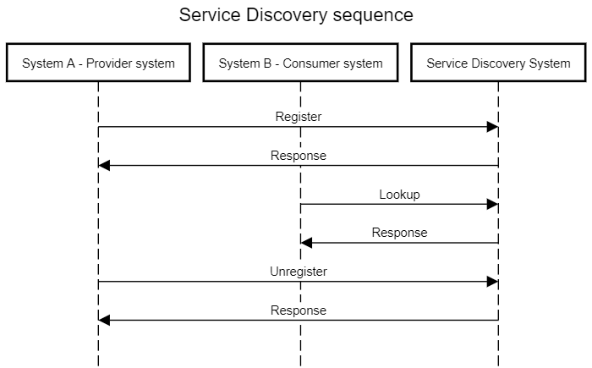

1. Information Model

# Struct RegistrationItem

The data structure used in registration of a service should contain information about the service type, the service logical name/id and an endpoint.

Optional information can contain a unique service instance identifier and metadata about the instance. A “Time to Live” value is a part of the optional information.

# Struct Instance

The instance data structure contains an identity of a service instance. It can be a name or an GUID.

# Struct MatchingInfo

The MatchingInfo data structure contains information used to find a service in the Service Discovery providing system. The structure is a list of keywords and values where the following attributes are mandatory (can be empty or wildcarded):

|  |  |
| --- | --- |
| Key | Type |
| Name | String |
| ServiceType | String |

Other attributes can be present and will be matched in any suitable way.

1. Non-functional Requirements

No non-functional requirements have been defined.

1. References

No references have been identified.

1. Revision history

# Amendments

|  |  |  |  |  |
| --- | --- | --- | --- | --- |
| No. | Date | Version | Subject of Amendments | Author |
| 1 | 2022-06-08 | 0.1 | Initial draft of specification | Per Olofsson |

# Quality Assurance

|  |  |  |  |
| --- | --- | --- | --- |
| No. | Date | Version | Approved by |
| 1 |  |  |  |
| 2 |  |  |  |